ANALYSIS OF THE SUNYAEV-ZEL’DOVICH (SZ) EFFECT USING THE ACT DR5 CLUSTERS CATALOG

ANDREW COHEN

12/13/20

ABSTRACT

I present analysis of 4195 optically confirmed SZ galaxy clusters. Python was used to plot relationships between cluster mass, redshift, right ascension angle, and calculate the distortion of the Planck spectrum due to the SZ effect.

INTRODUCTION

Galaxy clusters are structures of hundreds to thousands of galaxies bound together by gravity. They typically possess masses between 1015-1014 solar masses. Galaxy cluster observations are utilized because they evolve very slowly, thus they act as a probe into cosmological history. Furthermore, since clusters are mostly held together by the gravity that arises from dark matter, they provide an excellent avenue to study this phenomenon. One such method of study is the mass function, which provides the mass evolution of a galaxy cluster. The Halo Mass Function is particularly useful in dark matter analysis.

The Cosmic Microwave Background (CMB) is the nearly uniform background of radio waves that occupy the universe. The CMB is in effect an imprint from the Big Bang and as such is crucial to the study of our universe’s evolution. The Sunyaev-Zel’dovich (SZ) effect causes distortions in the CMB that arise from inverse Compton scattering of the CMB photons by electrons withing the atmospheres of galaxy clusters. Because the SZ effect distorts the brightness of the CMB due to the structure and thermal conditions of the gas within galaxy clusters, it is a useful tool in order to investigate the mass and atmospheres of the clusters. One of the unique features of the SZ effect is that it is redshift independent. Thus, the SZ effect can be used to measure the distance of a cluster and as a probe of cosmological parameters such as the Hubble constant.

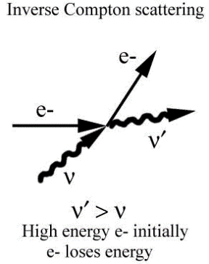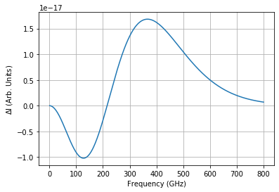

Figure 1: Planck Spectrum Distortion caused by the SZ effect from data in the DR 5 Catalog

DATA SET

The data set analyzed in the study comes from the ACT DR5 Clusters catalog. The catalog, whose data was obtained by the Atacama Cosmology Telescope (ACT) from 2008-2018, contains 4195 optically confirmed SZ selected galaxy clusters. The clusters span the redshift range 0.04 < z < 1.91 and a 90% completeness mass limit of f M500c > 3.8 × 1014 M☉, evaluated at z = 0.5. The search area of the catalog covers 13,211 deg2.

For this project four plots were created using the data from the catalog. The first two plots display the relation between the cluster right ascension angle and redshift and cluster mass and redshift respectively.

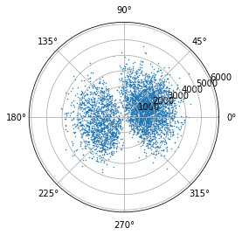

Figure 2: Right Ascension Angle (Radians) vs. Comoving Distance. Each point represents a cluster in the catalog. Comoving distance DC between two nearby objects in the Universe is the distance between them which remains constant with epoch if the two objects are moving with the Hubble flow. In other words, it is the distance between them which would be measured with rulers at the time they are being observed (the proper distance) divided by the ratio of the scale factor of the Universe then to now.

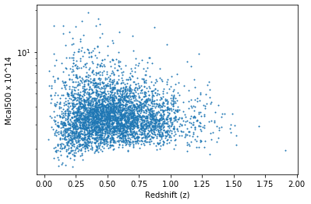

Figure 3: Rescaled Mass (1014 M☉) vs. Redshift. Each point is a different cluster, The ACT DR5 SZ masses displayed have been rescaled according to a richness-based weak-lensing mass calibration.

ANALYSIS

One of the most important investigative tools derived form cluster data are mass functions which allow for the examination of cluster mass evolution, which is essential for studying dark matter. The Halo Mass Function of the ACT DR 5 Catalog data is plotted in Figure 3. The Halo Mass Function predicts how many galaxy halos of a certain mass there should be in a comoving volume. A galaxy halo is a hypothetical region of a galaxy cluster that contains gravitationally bound matter and is decoupled from cosmic expansion. They are prime candidates for dark matter studies. The Halo Mass Function plotted comes from *Press and Schecter* (1974)*.*

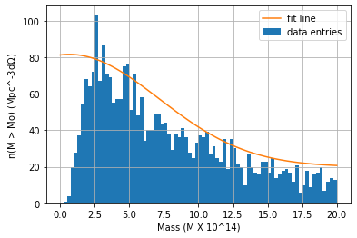

Figure 4: Halo Masses binned and normalized. A fit line was added to demonstrate the Halo Mass Function trend.

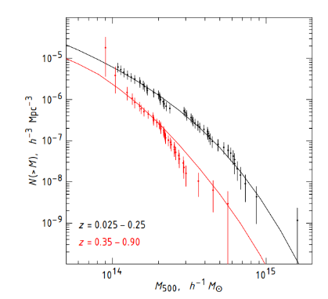

Figure 5: Estimated mass functions for our cluster samples (A. Vikhlinin et al. 2009)

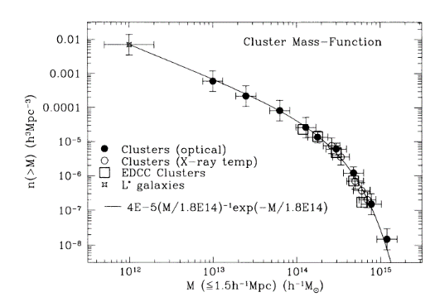

Figure 6: Cluster Mass Function (Bahcall and Cen 1992)

DISCUSSION

Comparing the mass functions of the DR 5 catalog to other mass function studies shows that the mass function of DR 5 is order of magnitudes lower than the two other studies observed here in Figures 4 and 5. This is due to the ACT’s observation methods which results in a large variation in the mass completeness of the survey. As discussed in section 2.4 of Hilton et al., the DR 5 catalog only possesses an approximately 90% survey completeness. This survey bias thus leads to the discrepancies between the mass functions.

CONCLUSION

Galaxy cluster catalogs such as the one discussed in this report (ACT DR 5) are databases critical to the ongoing investigation of cosmological phenomenon. They present opportunities to study cosmological parameters, the evolution of the universe, the behavior of dark matter, and the Sunyaev-Zel’dovich Effect. Even with elementary study of these catalogs incredibly significant data can be analyzed.

REFERENCES

1. Hilton, M., & et al. The Atacama Cosmology Telescope: A Catalog of > 4000 Sunyaev-Zel'dovich Galaxy Clusters. United States.
2. Vikhlinin, A. et al. Chandracluster Cosmology Project Iii: Cosmological Parameter Constraints. The Astrophysical Journal 692, 1060–1074 (2009).
3. Bahcall, N. A. and Cen, R., “The Mass Function of Clusters of Galaxies”, <i>The Astrophysical Journal vol. 407, p. L49, 1993. doi:10.1086/186803.
4. Venables, J., Neakrase, J., &amp; Neal , J. Photoelectrons, Compton and Inverse Compton Scattering. <http://venables.asu.edu/quant/proj/compton.html>.
5. Birkinshaw, M. THE SUNYAEV-ZEL'DOVICH EFFECT. The Sunyaev-Zel'dovich Effect. <https://ned.ipac.caltech.edu/level5/Birkinshaw/Birk_contents.html>.